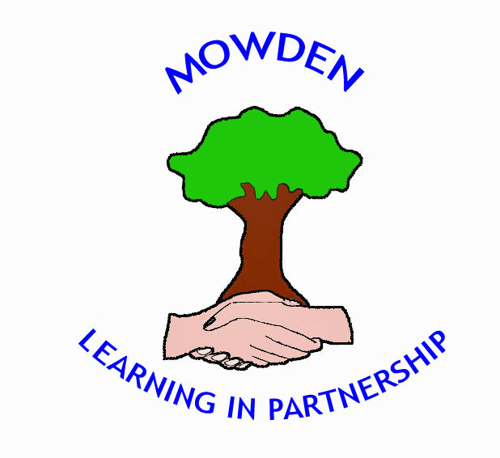

Headteacher: Peter King
Tel: 01325 380820
Email: family@mowden.darlington.sch.uk
www.mowdenfederation.co.uk

Date:

Change of lunch arrangement from packed lunch to school dinner.

I would like my child to receive a school dinner from:-

Monday ……………………………………………………..………………………(insert date)

I understand a minimum of one week’s notice is required.

Name of Child ………………………………………….……………….. Class ………..…….

Vegetarian  Vegan  Halal | YES/NO  YES/NO  YES/NO
Please let us know if your child has any food allergies, intolerances or special dietary requirements:

……………………………………………………………………………………………………...

………………………………………………………………………………………………………

………………………………………………………………………………………………………

………………………………………………………………………………………………………

Signed………………………………………………………………..……………………………..

Name…………………………………..……………………..………………… Parent/Guardian

We will contact you to confirm the change to school dinners.

Payment for school dinners, (junior school children), can be made weekly, monthly or half termly in advance via ParentMail. Free school meals are available upon application and are treated in the strictest confidence. Please contact the office if you think you are entitled.

